15 Nov 2025

ES 7018 – Independent Study (II)
Spatial Processing and Analysis in R

Graduate student: Geoff Lim
Matriculation No: G2409151L
Title of Project: Geospatial Analysis of Forest Loss in PICOP, Bislig, an Important Bird Area (IBA) in Mindanao

Introduction
The Philippines, a nation globally recognized as a hotspot of biodiversity, is simultaneously grappling with a severe deforestation crisis (Heaney and Regalado, 1998; Posa and Sodhi, 2006). Once extensively forested, the country's tree cover has been drastically reduced in recent decades, with current estimates at just 24.09% of the total land area (Forest Management Bureau, 2021; Agduma et al., 2023; Apan et al., 2017). The southern island of Mindanao, which constitutes 34% of the nation's landmass, harbours forests with a high degree of endemism, yet comprehensive biodiversity data for its unique fauna remains incomplete (Agduma et al., 2023). Deforestation in Mindanao is driven by multiple factors, including agricultural expansion through traditional kaingin (shifting cultivation), the large-scale conversion of forests for cash crops, and the pervasive impacts of the mining and extraction industry (Agduma et al., 2023; Recuenco, 2022; Apan et al., 2017).
The national strategy of establishing Protected Areas (PAs) to safeguard pristine forests has proven to be only marginally effective in curbing this decline. A nationwide study from 2000 to 2012 revealed a forest loss rate of 2.59% within these protected zones, a figure negligibly lower than the national average of 2.69% (Apan et al., 2017). This indicates that the PA system has not been a panacea for deforestation. This systemic failure is starkly illustrated by the case of the former Paper Industries Corporation of the Philippines (PICOP) concession near Bislig, Mindanao. Following the corporation's decline, a power vacuum emerged, leaving the forest as a "free-for-all for informal settlers, illegal loggers, [and] poachers" (Malonzo & Orodio, 2025). The situation has become so dire that individuals with chainsaws are observed operating openly in the area (pers. obs.; Robson, 2023).
Despite this history of logging and extensive degradation, the PICOP landscape—a mosaic of remnant primary forest, secondary growth, and forest edge—paradoxically persists as a site of immense ecological importance. Officially designated as a Key Biodiversity Area (KBA) of international significance, PICOP is one of the premier locations for observing Mindanao's rare lowland forest birds (BirdLife International, 2025; Yong and Low, 2018). Birdwatchers are drawn to the area for its populations of threatened and iconic species, including the Celestial Monarch, Azure-breasted Pitta, Southern Silvery Kingfisher, and various endemic hornbills (Malonzo & Orodio, 2025; Robson, 2023). This highlights PICOP's critical role as a "last-stand" refuge for endemic species in a disturbed landscape (Tabora et al., 2023; Zapanta et al., 2019).
Furthermore, birding tourism offers a substantial economic alternative to destructive practices, with visitor expenditures estimated at USD 331 per day (Birdtour Asia, 2025). To foster effective management, a shift toward site-specific assessment is needed to protect such complex landscapes before their biodiversity is lost (Agduma et al., 2023; Tabora et al., 2023; Apan et al., 2017). Therefore, the objective of this study is to quantify the rate of forest loss in PICOP using geospatial methodologies, comparing current remote sensing data with a historical baseline to underscore the urgent need for its protection.
Methods
Study Area and Data Acquisition
This study utilized satellite remote sensing data to quantify environmental change within the Bislig Key Biodiversity Area (KBA) in Mindanao, Philippines, a region of high conservation priority. The study area boundary was defined using the Philippines_KBA.shp shapefile, which delineates globally significant sites identified by BirdLife International and its partners (BirdLife International, 2025). All analyses were constrained to an Area of Interest (AOI) defined by the following bounding box coordinates: xmin: 125.9641, ymin: 7.8266, xmax: 126.4167, and ymax: 8.4938.
The primary dataset consisted of Copernicus Sentinel-2 Level-2A products (European Space Agency, 2025). To facilitate the change detection analysis, imagery from two distinct time points was acquired: a baseline scene from 2016 (ID: T51PZK_20160721T021352) and a comparison scene from 2025 (ID: T51PZK_20250902T021231). The analysis specifically used the Red (Band 4) and Near-Infrared (NIR, Band 8) spectral bands from each scene, both of which have a 10-meter spatial resolution.
Data Preprocessing and Vegetation Index Calculation
To ensure a valid temporal comparison, the raw satellite imagery underwent preprocessing for spatial co-registration and radiometric normalization. The first step was the calculation of the Normalized Difference Vegetation Index (NDVI) for both the 2016 and 2025 datasets. This index serves as a quantitative measure of vegetation health and was computed using the standard formula:
NDVI = (NIR - Red) / (NIR + Red)
Following this calculation, the resulting NDVI rasters were aligned. To ensure a congruent pixel grid, the 2025 NDVI raster was resampled to match the spatial grid of the 2016 raster. Subsequently, both NDVI rasters were cropped to the precise spatial extent of the study area's bounding box.
Forest Cover Change Analysis
The primary analysis aimed to define forest versus non-forest cover and quantify the change between 2016 and 2025 using a baseline threshold of NDVI > 0.6 to classify forest pixels. "Forest loss" was defined as any pixel classified as forest in 2016 that was reclassified as non-forest in 2025. The total area of forest loss was calculated by summing the number of these converted pixels and multiplying by the area of a single pixel (0.01 hectares). To test the robustness of this definition, a sensitivity analysis was also conducted across a range of thresholds from 0.60 to 0.79.
Computational Environment
All data processing and analysis were performed in R version 4.5.1 (2025-06-13) using the RStudio environment. A suite of specialized R packages facilitated the geospatial operations. The terra package (version 1.8.60) was used for all raster data manipulations, including NDVI calculation, resampling, and classification. Vector data, such as the KBA shapefile, were handled with the sf package. Data summarization was performed with the dplyr package, and visualizations for the sensitivity analysis were created using ggplot2. The analytical workflow was linked to the core geospatial libraries GEOS (3.13.0), GDAL (3.8.5), and PROJ (9.5.1) to ensure reproducibility.
Results
Forest Area Change (2016–2025)
Using a baseline threshold of NDVI > 0.6 to define forest cover, the analysis of Sentinel-2 data revealed a net increase in forest area between 2016 and 2025. The total forest area in 2016 was calculated to be 113,542.51 hectares, which increased to 142,219.13 hectares in 2025. This constitutes a gross forest gain of 28,676.62 hectares, representing a 25.26% increase relative to the 2016 baseline. A summary of these findings is presented in Table 1.
Table 1. Forest area change between 2016 and 2025 based on an NDVI threshold of > 0.6.
Initial Year | Final Year | Forest Area in 2016 (ha) | Forest Area in 2025 (ha) | Forest Loss (ha) | Percent Change in Forest Area
2016 | 2025 | 113,542.51 | 142,219.13 | 69,900.13 | 61.56
Sensitivity of Loss Estimates to NDVI Threshold Definition
To assess the robustness of the findings, a sensitivity analysis was conducted to determine how the estimate of forest change varies with the NDVI threshold used to define "forest." This was accomplished by systematically recalculating forest area and change across NDVI thresholds ranging from 0.60 to 0.79 (see Figure 1 below).

Figure 1 – Sensitivity of Forest Loss to NDVI Threshold
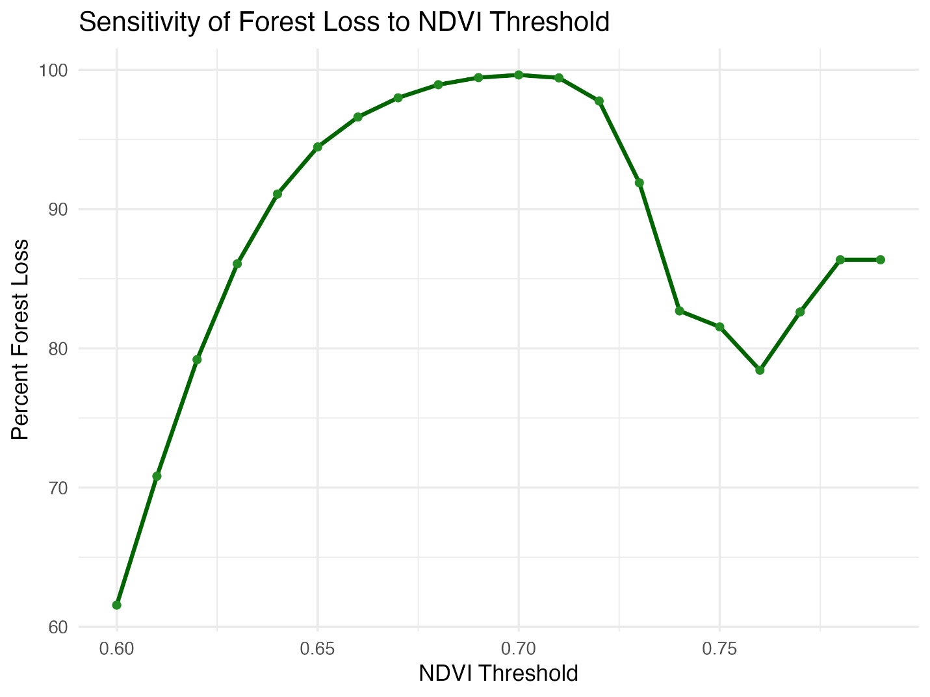

The analysis revealed a distinct pattern: thresholds from NDVI > 0.60 to 0.61 indicated a moderate forest loss, while thresholds from NDVI > 0.62 to 0.70 showed progressively greater forest loss. The calculated forest loss peaked at 99.63% with an NDVI threshold of 0.70. The detailed results of this sensitivity analysis are provided in Table 2.

Table 2. Forest area change based on varying NDVI thresholds.
NDVI Threshold | Forest Area in 2016 (ha) | Forest Area in 2025 (ha) | Forest Loss (ha) | Percent Change in Forest Area
0.6 | 113542.51 | 142219.13 | 69,900.13 | 61.56
0.61 | 85891.65 | 95955.41 | 60829.27 | 70.82
0.62 | 61095.99 | 59688.77 | 48380.65 | 79.19
0.63 | 40666.53 | 34244.54 | 35001.88 | 86.07
0.64 | 25110.03 | 18249.28 | 22870.66 | 91.08
0.65 | 14211.45 | 9057.48 | 13423.89 | 94.46
0.66 | 7311.65 | 4141.9 | 7063.62 | 96.61
0.67 | 3382.14 | 1690.23 | 3314.29 | 97.99
0.68 | 1397.06 | 580.09 | 1382.06 | 98.93
0.69 | 515.48 | 158.02 | 512.6 | 99.44
0.7 | 168.42 | 32.11 | 167.8 | 99.63
0.71 | 46.94 | 3.93 | 46.67 | 99.42
0.72 | 10.71 | 0.33 | 10.47 | 97.76
0.73 | 2.59 | 0.03 | 2.38 | 91.89
0.74 | 1.04 | 0 | 0.86 | 82.69
0.75 | 0.65 | 0 | 0.53 | 81.54
0.76 | 0.51 | 0 | 0.4 | 78.43
0.77 | 0.46 | 0 | 0.38 | 82.61
0.78 | 0.44 | 0 | 0.38 | 86.36
0.79 | 0.44 | 0 | 0.38 | 86.36
Discussion
The study's primary analysis yielded a 69,900.13ha (61.56%) forest loss when using a baseline NDVI threshold of > 0.6. This finding appears confounding as the numerical difference between the forest cover in 2016 and 2025 showed a net increase in forest cover of 28,676.62ha (25.26%). Literature searches have not been able to directly substantiate this observation; however, there have been some oblique references that suggest limitations in using NDVI values alone to assess forest loss. For example, Mancino et al (2025) indicated that other methods, such as Post Classification Comparison (PCC) yield better results than NDVI. They also highlighted that “Selecting a suitable threshold for change detection is a challenging and time-consuming process that requires considerable skill.” Bourgoin et al (2024) also showed that additional remote sensing tools, such as LIDAR, and further analytical methods, such as canopy height (RH98), height of median energy (RH50) and aboveground biomass density (AGBD), were required to elucidate deeper insights into forest degradation and loss. Finally, The Forest Declaration Assessment partners (2025:31) explained that there is substantial regrowth of forest since 2015 globally, suggesting recovery. However, such statistics could suggest increased deforestation, leading to new areas for regrowth, as well as possible abandoning of deforested lands. These references can lend credence to the forest loss figures derived in the Results section, suggesting that the regrowth of secondary forests or agriculture has contributed to increased forest cover, while forest loss has indeed been occurred during the intervening period.
To contextualize these findings, a comparison was made with data from Global Forest Watch (GFW) for the Bislig-Visayas area, using the same KBA boundary (Global Forest Watch, 2025). The GFW dashboard indicates a 25% decrease in primary forest area between 2002 and 2024 and a 28% loss of total tree cover between 2001 and 2024. A direct comparison between this study's results and GFW data is not appropriate, as the time periods differ significantly and GFW utilizes a combination of metrics beyond NDVI to derive its estimates (World Resources Institute, 2025).
Conclusion
This study highlights the complexity of measuring forest change in a dynamic conservation landscape like PICOP, Bislig. By leveraging satellite-derived NDVI, it demonstrates that estimates of forest cover change are highly sensitive to the analytical threshold applied, underscoring the necessity for careful calibration and transparent reporting in remote sensing analyses.
The comparison with Global Forest Watch data reinforces a broader conservation lesson: the ecological value of human-modified and fragmented forests should not be underestimated. As supported by existing research, disturbed landscapes in Mindanao, including agroforests within protected areas, can serve as vital refugia for threatened and endemic biodiversity (Tabora et al., 2023; Panopio et al., 2021; Zapanta et al., 2019). This evidence points to an urgent need to expand conservation efforts beyond pristine, intact forests to encompass these critically important, human-modified landscapes.
Protecting sites like PICOP demands the implementation of adaptive, fine-scale monitoring and the formal integration of disturbed yet ecologically significant habitats into conservation policy and practice. The need for targeted, site-level action is clear if Mindanao’s irreplaceable forest ecosystems and their unique biodiversity are to be secured for the future.

References
Agduma, A. R., Garcia, F. G., Cabasan, M. T., Pimentel, J., Ele, R. J., Rubio, M., Murray, S., Hilario-Husain, B. A., Cruz, K. C. D., Abdullah, S., & Balase, S. M. (2023). Overview of priorities, threats, and challenges to biodiversity conservation in the southern Philippines. Regional Sustainability, 4(2), 203–213. https://doi.org/10.1016/j.regsus.2023.05.003
Apan, A., Suarez, L. A., Maraseni, T., & Castillo, J. A. (2017). The rate, extent and spatial predictors of forest loss (2000–2012) in the terrestrial protected areas of the Philippines. Applied Geography, 81, 32–42. https://doi.org/10.1016/j.apgeog.2017.02.007
BirdLife International (2025) Site factsheet: Bislig. Downloaded from https://datazone.birdlife.org/site/factsheet/9786-bislig on 14 November 2025.
Birdtour Asia. (2025). Philippines 2027. Retrieved 14 November 2025, from https://www.birdtourasia.com/philippines2027
Bourgoin, C., Ceccherini, G., Girardello, M., Vancutsem, C., Avitabile, V., Beck, P. S. A., Beuchle, R., Blanc, L., Duveiller, G., Migliavacca, M., Vieilledent, G., Cescatti, A., & Achard, F. (2024). Human degradation of tropical moist forests is greater than previously estimated. Nature, 631(8021), 570. https://doi.org/10.1038/s41586-024-07629-0
European Space Agency (2025). Copernicus browser. Copernicus Data Space Ecosystem. Retrieved November 14, 2025, from https://browser.dataspace.copernicus.eu/
Forest Management Bureau (2021). Philippine forestry statistics 2021. Accessed from https://drive.google.com/file/d/1V2JS74DPvMc4A8r3AJwrMDoAmXptI9f/view?usp1⁄4embed_facebook on 14 November 2025.
Forest Declaration Assessment Partners. (2025, October 13). Forest Declaration Assessment 2025. Climate Focus (coordinator and editor). https://forestdeclaration.org/resources/forest-declaration-assessment-2025. Assessed on 25 November 2025.
Global Forest Watch. (2025). Area of interest dashboard. Global Forest Watch. https://www.globalforestwatch.org/dashboards/aoi/68cc0c7e387a230015df4f4c/?map=eyJjYW5Cb3VuZCI6dHJ1ZX0%3D. Accessed on 15 November 2025.
Heaney, L. R., & Regalado, J. C., Jr. (1998). Vanishing treasures of the Philippine rain forest. Illinois: The Field Museum.
Mancino, G., Falciano, A., & Trivigno, M. L. (2025). Change Detection methods for forest expansion assessment in the last twenty years in the Mediterranean Basin. iForest - Biogeosciences and Forestry, 18(2), 69. https://doi.org/10.3832/ifor4634-018
Malonzo, D., & Orodio, R. (2025, April 12). Club Trip: PICOP January 2025. Wild Bird Club of the Philippines. https://birdwatch.ph/club-trip-picop-january-2025/ Accessed on 13 November 2025.
Panopio, J. K., Pajaro, M., Grande, J. M., Dela Torre, M., Raquino, M., & Watts, P. (2021). Conservation Letter: Deforestation—The Philippine Eagle as a case study in developing local management partnerships with Indigenous Peoples. Journal of Raptor Research, 55(3), 460–467.
Perplexity (2025a). Report on Forest Loss. https://www.perplexity.ai/search/provide-me-with-a-brief-report-qRgulFpPTPC3nqpj59eZQg. Assessed on 25 November 2025.
Perplexity (2025b). Report on Forest Loss. https://www.perplexity.ai/search/you-are-tasked-with-writing-a-ZvIh2BGQQnGvrKhJBtK9hA. Assessed on 25 November 2025.
Posa, M. R. C., & Sodhi, N. (2006). Effects of anthropogenic land use on forest birds and butterflies in Subic Bay, Philippines. Biological Conservation, 129(2), 256–270. https://doi.org/10.1016/j.biocon.2005.10.041
Recuenco, A. (2022, November 9). DENR identifies 9M hectares of potential mining areas. Manila Bulletin. https://mb.com.ph//2022/11/09/denr-identifies-9m-hectares-of-potential-mining-areas/
Robson, C. (2023). Classic Philippines tour report 2023. Birdquest. https://www.birdquest-tours.com/birding-tours/classic-philippines/tour-report/2023/
Tabora, J. A. G., Ancog, R. C., Sanchez, P. A. J., Arboleda, M. D. M., Lit, Jr., I. L., & Tiburan, Jr., C. L. (2023). The last stand of a watershed forest in Southern Philippines: A case study of land cover and biodiversity. Biodiversitas, 24(3), 1438–1449. https://doi.org/10.13057/biodiv/d240313
World Resources Institute. (2025). Data & methods. Global Forest Review. https://gfr.wri.org/data-methods. Accessed on 15 November 2025.
Yong, D. L., & Low, B. W. (2018). The 125 best birdwatching sites in Southeast Asia. John Beaufoy Publishing.
Zapanta, B. R., Achondo, M. J. M. M., Raganas, A. F. M., Camino, F. A., Delima, A. G. D., Mantiquilla, J. A., Puentespina, Jr. R. P., & Salvaña, F. R. P. (2019). Species richness of trees in disturbed habitats within a protected area and its implications for conservation: The case of Mt. Apo Natural Park, Mindanao Island, Philippines. Biodiversitas, 20(7), 2081–2091. https://doi.org/10.13057/biodiv/d200740

